6A^{th} Grade: Unit 15, Lesson 2

- Is choosing a card at random from a deck of cards considered a simple experiment?

Yes

- If an event is said to be more probable, what does this mean for the event?

It means the event will most likely occur.

- A table of events is shown. From the information in the table, which event has a greater likelihood of occurring?
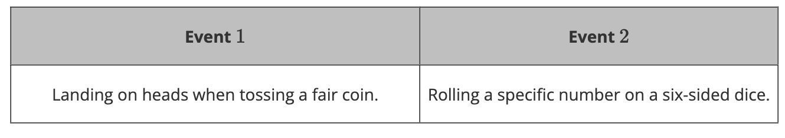

Event 1

